An Algebraic Approach to Geometric Proof Using a Computer Algebra System

Michael Xue
Vroom Laboratory for Advanced Computing (US)
mxue@vroomlab.com

Geometric proof is often considered to be a challenging subject in mathematics.
The traditional approach seeks a tightly knitted sequence of statements linked together by strict logic to prove that a theorem is true. Moving from one statement to the next in traditional proofs often demands clever, if not ingenious reasoning. An algebraic approach to geometric proof, however, is more direct and algorithmic in nature. It is based on the assumption that proving a geometric theorem essentially means solving a problem in algebra. More precisely, it means solving a system of algebraic equations. An algebraic approach typically consists of the following steps:

Step-0. An appropriate coordinate system is chosen.

Step-1. The relationships between geometric elements are translated into a system of algebraic equations based on geometric data (e.g., coordinates of points, lengths and slopes of line segments, areas of figures, etc.). The expression that implies the thesis statement is identified.

Step-2. Solving equations in Step-1 by built-in solver in the existing Computer Algebra software. The thesis statement is then shown to be a consequence of evaluating the expression identified in Step-1 using the appropriate solution(s).

Due to the tremendous amount of calculation involved in the process, the algebraic approach becomes feasible only with the aide of Computer Algebra System’s (CAS) powerful symbol manipulation capability. This presentation will demonstrate the algebraic approach to geometric proof by three examples using Omega, an online CAS Explorer.

Example-1

We begin with a proof of Heron’s formula concerning the area of any triangle, namely,

$A=\sqrt{s(s-a)(s-b)(s-c)}$ [1-0]

where$a,b,c$are the three sides of the triangle and, $s=\frac{a+b+c}{2}$.

Substituting $s$into [1-0], the formula becomes

$A=\sqrt{\frac{(a+b+c)(-a+b+c)(a-b+c)(a+b-c)}{16}}$ [1-1]

A triangle with three known sides is shown in Fig. 1 where $x$ is part of the base of the triangle.
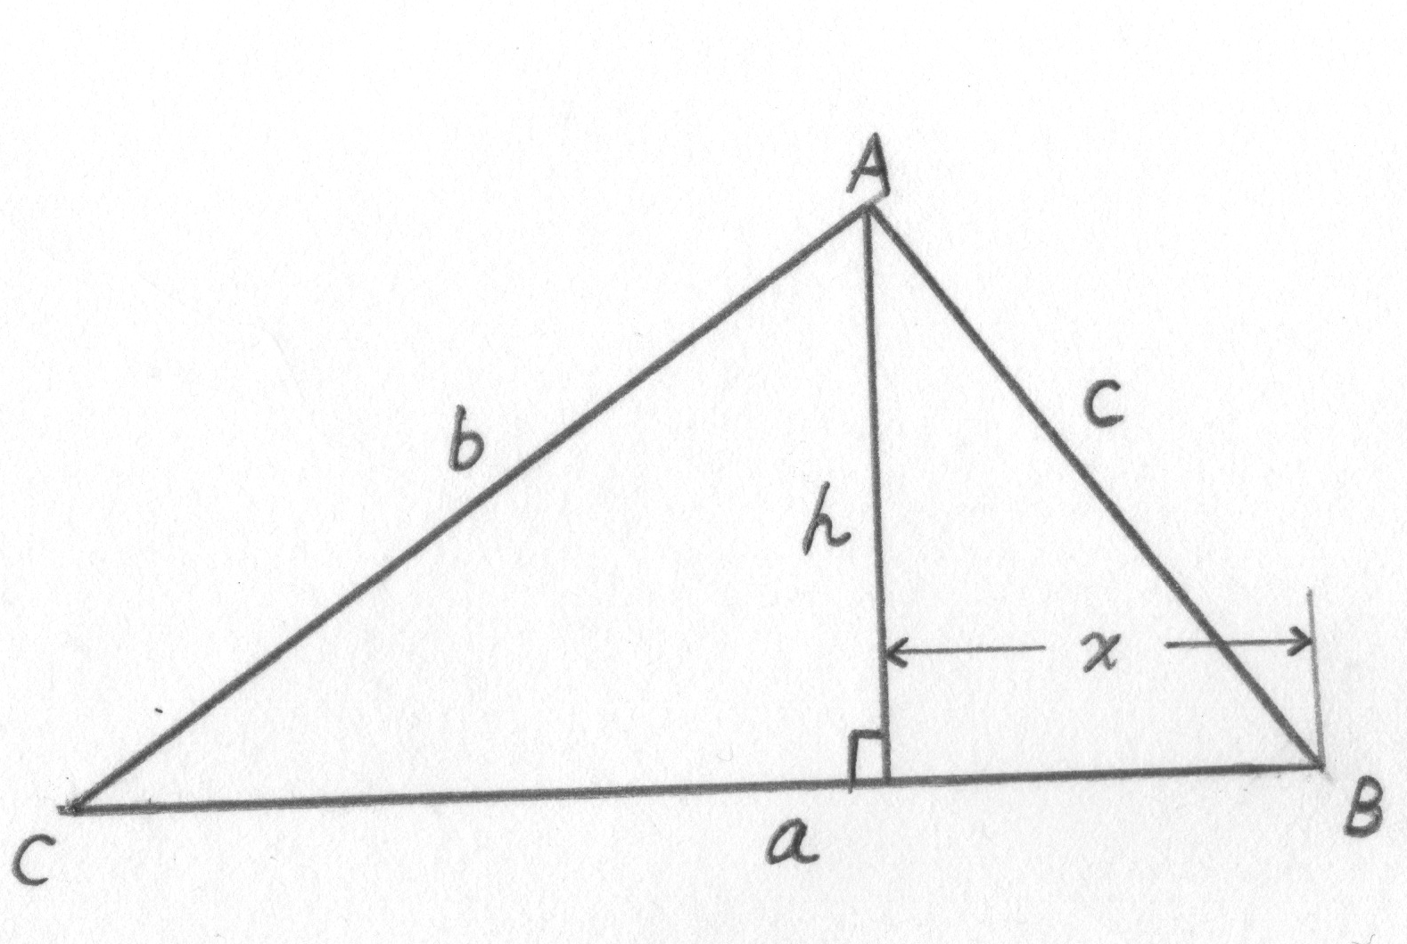
Fig. 1

By Pythagorean theorem:
$$h^{2}+ x^{2}=c^{2}$$
$$h^{2}+({a-x)}^{2}=b^{2}$$

To obtain $h^{2}$, we will use the following script of Omega Computer Algebra Explorer
(http://www.vroomlab.com)

eq1:h^2+x^2-c^2$
eq2:h^2+(a-x)^2-b^2$
eliminate([eq1, eq2], [x, h^2])$
factor(%[1]);

The ‘eliminate’ eliminates variable $x$, returns the value of $h^{2}$.
The script yields
$${ h}^{2} =\frac{(a+b+c)(-a+b+c)(a-b+c)(a+b-c)}{4a^{2}}.$$
Therefore,
$$A=\frac{1}{2} a h=\sqrt{\frac{(a+b+c)(-a+b+c)(a-b+c)(a+b-c)}{16}}$$
which is [1-1].

Example-2
Given $ΔABC$ and two squares $ABEF, ACGH$ in Fig. 2-0. The squares are sitting on two sides of $ΔABC$,$AB$ and $AC$, respectively. Both squares are oriented away from the interior of $ΔABC$. $ΔBCP$ is an isosceles right triangle.$P$is on the same side of $A$. Prove: Points $E,P,$ and $G$ lie on the same line.
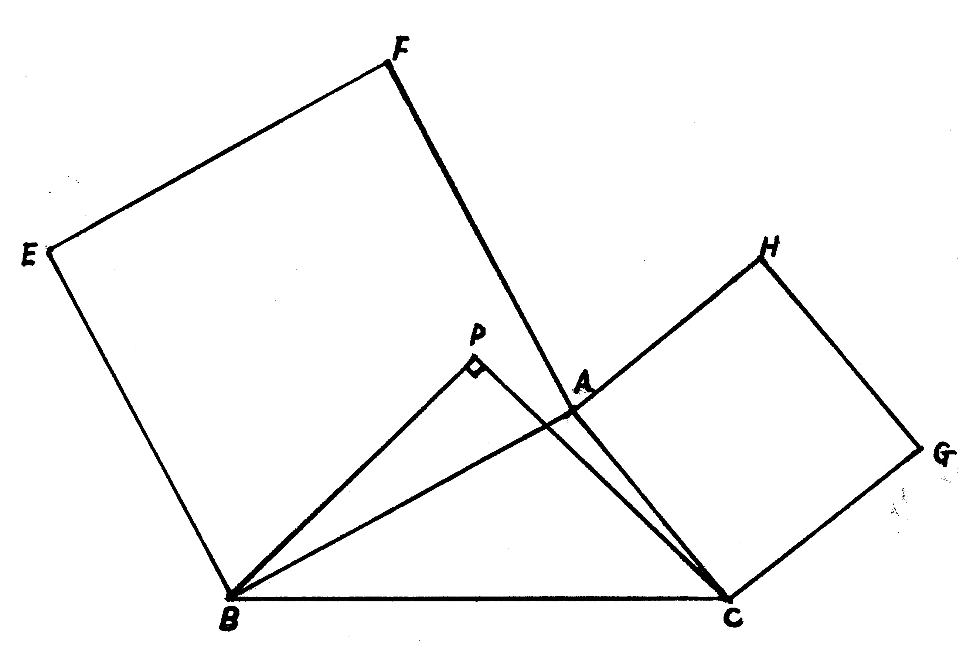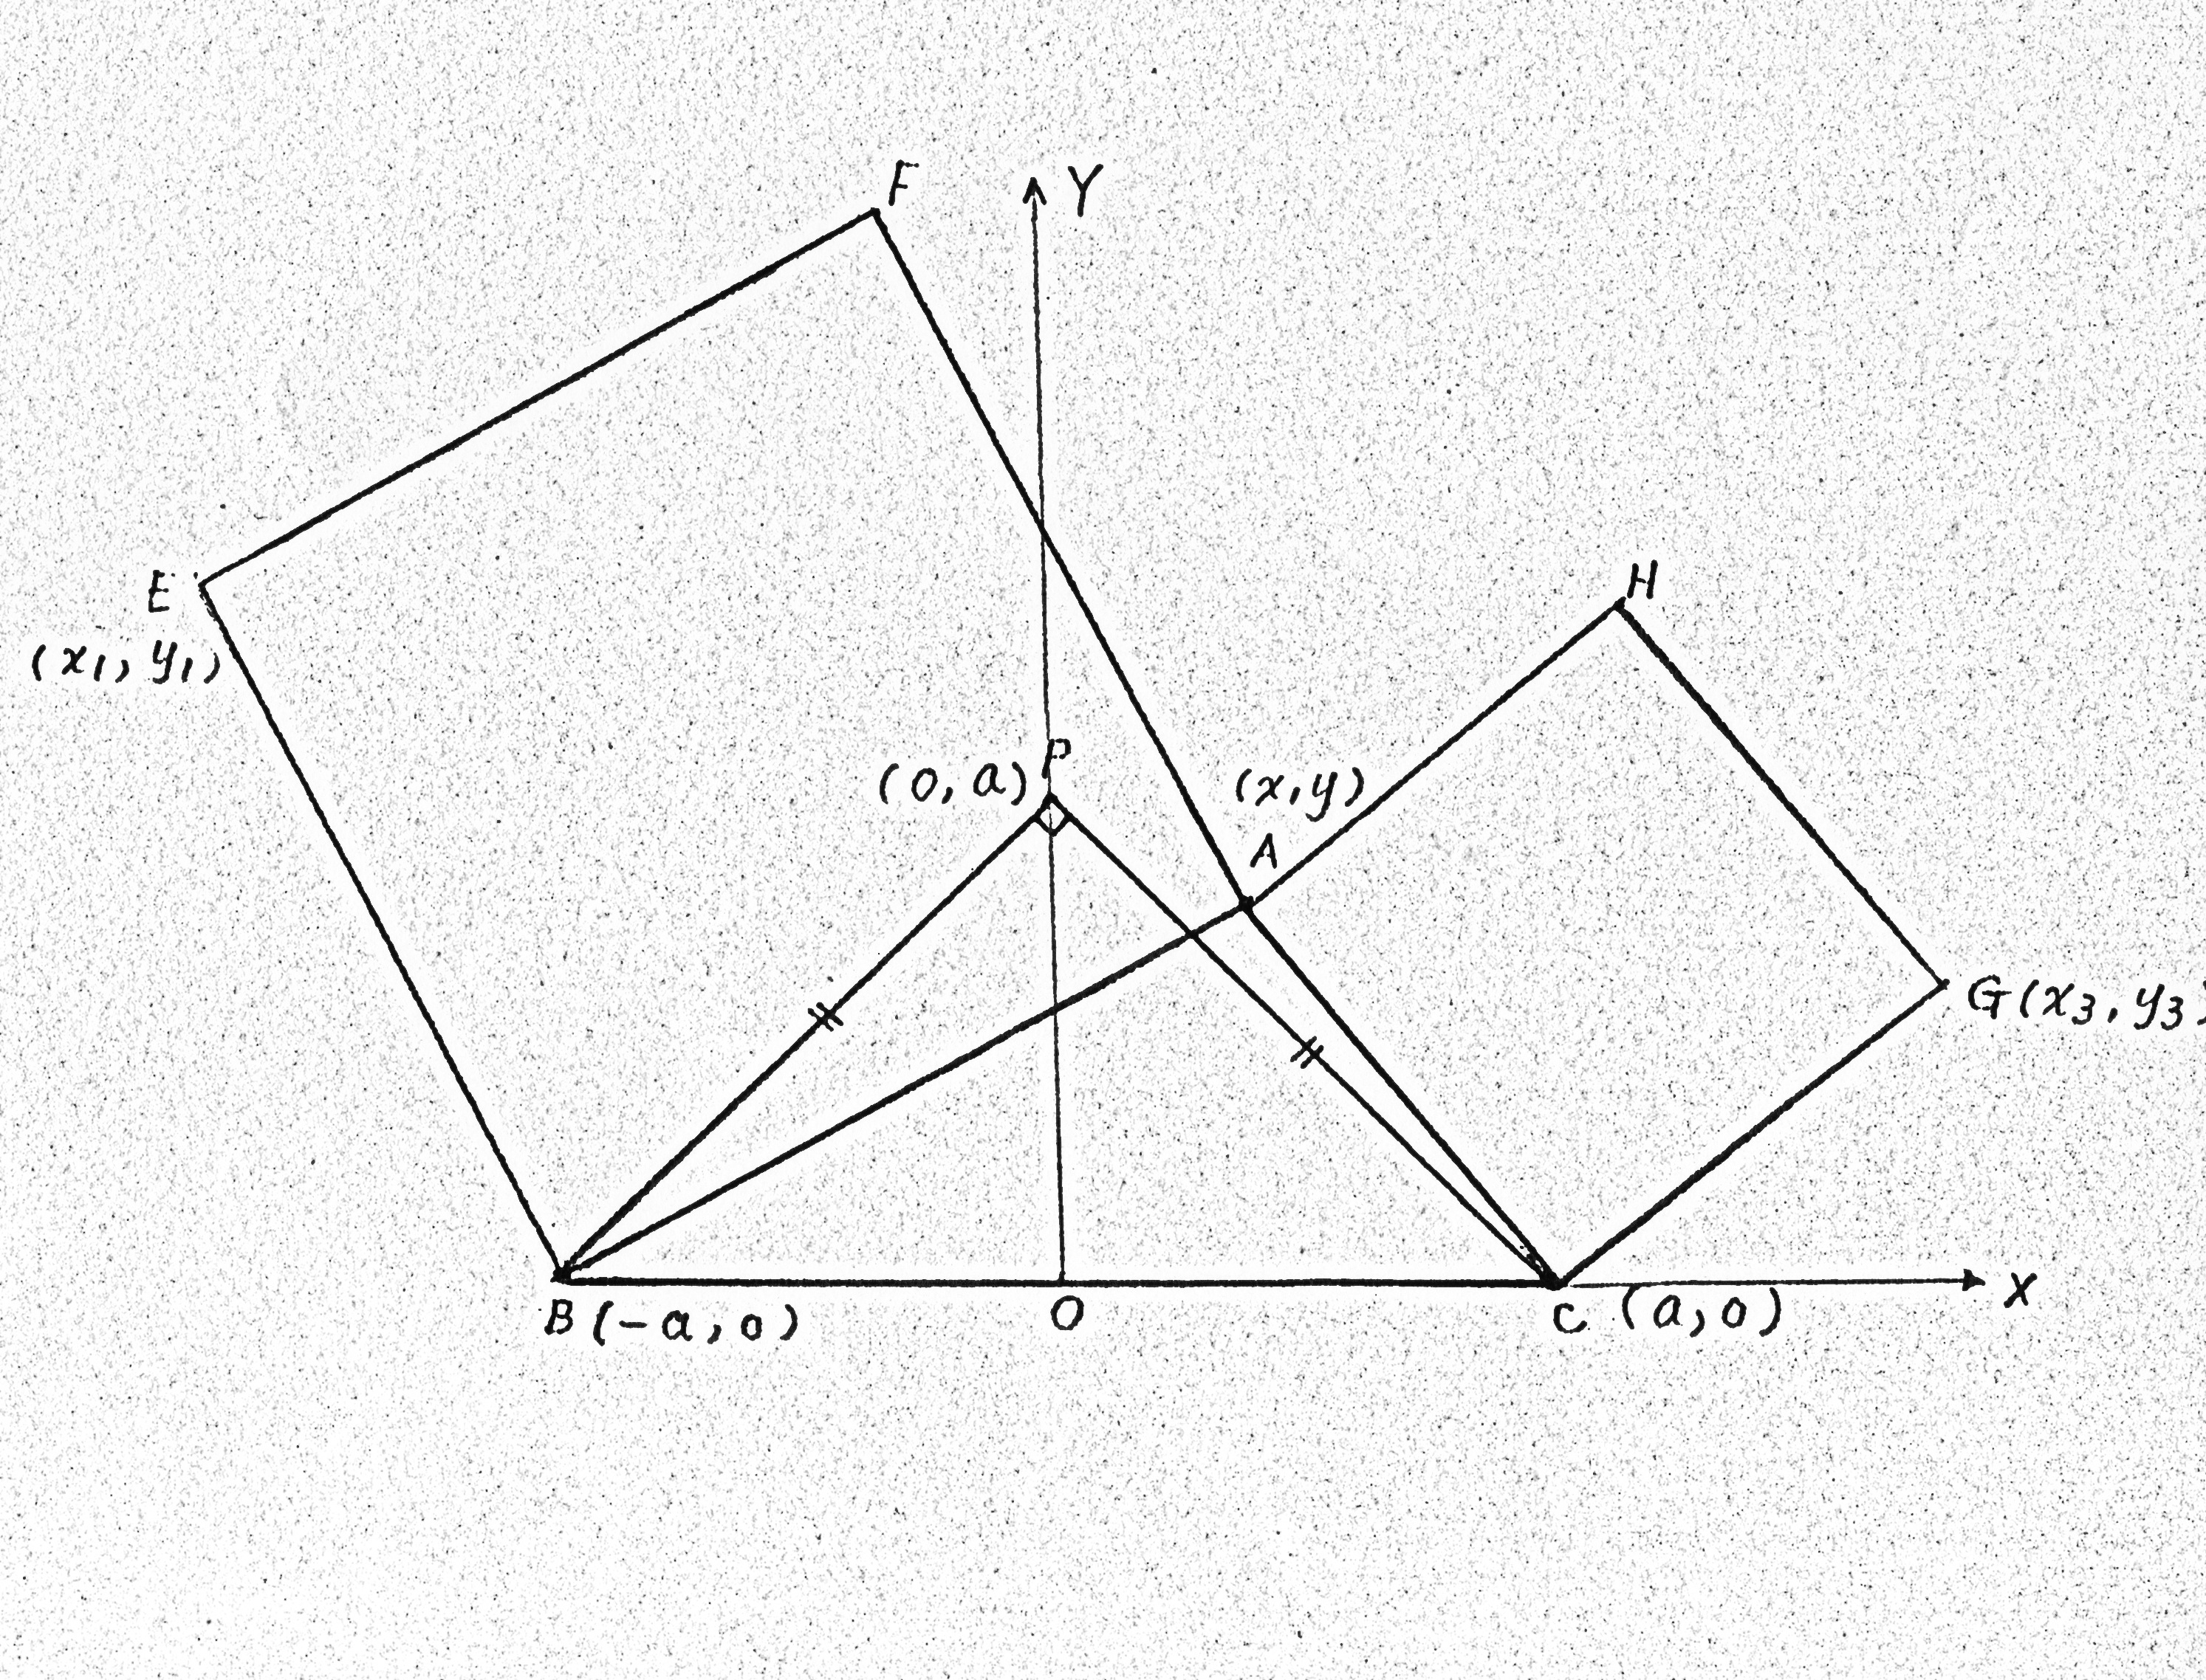
Fig. 2-0 Fig. 2-1

Introducing rectangular coordinates shown in Fig. 2-1.
From Fig. 2-1, we observe that

$y>0$ [2-0]
$x_{1}<-a$ [2-1]
$x_{3}>a$ [2-2]

$CG=CA⇒({x_{3}-a)}^{2}+ y_{3}^{2}= {\left(x-a\right)}^{2}+ y^{2}$ [2-3]
$AB=BE⇒{(x+a)}^{2}+ y^{2}= {(x_{1}+a)}^{2}+ y_{1}^{2}$ [2-4]
$CG⊥ CA{⇒y}_{3}y=-(x-a)(x_{3}-a)$ [2-5]
$BE⊥AB⇒ y_{1}y=-(x_{1}+a)(x+a)$ [2-6]

Solving systems of equation [2-3], [2-4], [2-5], [2-6], we obtain four set of solutions:

$x_{1}=-y-a, y_{1}=x+a,x_{3}=y+a,y_{3}=a-x$ [2-7]
$x_{1}=y-a, y_{1}=-x-a,x_{3}=y+a,y_{3}=a-x$ [2-8]
$x_{1}=-y-a, y_{1}=x+a,x_{3}=a-y,y_{3}=x-a$ [2-9]
$x_{1}=y-a, y_{1}=-x-a,x_{3}=a-y,y_{3}=x-a$ [2-10]

Among them, only [2-7] truly represents the coordinates in Fig. 2-1. The determinant

is zero which implies that $E,P,$and $G$ are on the same line. See Fig. 2-2

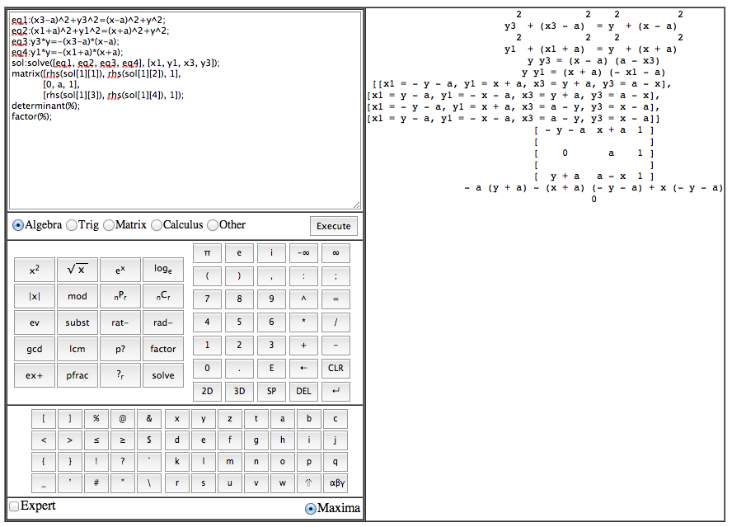
Fig. 2-2

The reason we do not consider [2-8], [2-9], [2-10] is due to the fact that [2-8] contradicts [2-1] since $y>0, a>0⇒x_{1}=y-a= -a+y>-a.$By [2-0],[2-9] and [2-10] indicate$x_{3}=a-y<a$, which contradicts [2-2].

Example-3

The area A of a triangle by three points $\left(x_{1}, y_{1}\right), \left(x_{2}, y_{2}\right), \left(x_{3}, y_{3}\right)$ in a rectangular coordinate system can be expressed as $\left|\frac{1}{2}D\right|$, where D is the determinant of matrix:

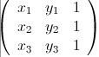

By Heron’s formula [1-0] in Example-1, $A^{2}=s(s-a)(s-b)(s-c)$. Let
${B=\left|\frac{1}{2}D\right|, B}^{2}={\left|\frac{1}{2}D\right|}^{2}={\left(\frac{1}{2}D\right)}^{2}$ .

It is shown by Computer Algebra System that $A^{2}-B^{2}=0$ (See Fig. 3)

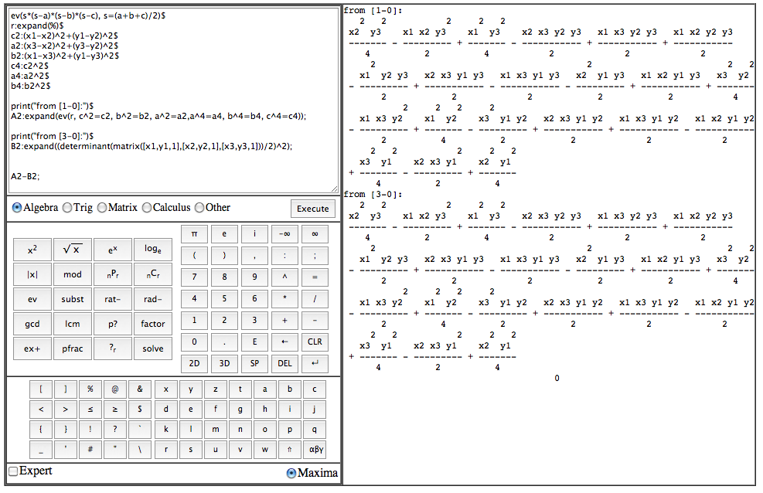

Fig. 3

$A^{2}-B^{2}=\left(A-B\right)\left(A+B\right)=0$ implies that A = B since both A and B are positive quantities.

