Dr. Jens Weitendorf, Norderstedt
Improving mathematical competences by using modern technology
Normally when you want to use modern technology in the classroom, you are looking for exercises for those it is easier to solve them using the technology.
In my talk I want to discuss an opportunity to deal with the curriculum on a higher level. This means that you do not have to change the curriculum but you have to change the point of view. The main issue will be the functional aspect of mathematical ideas. For example if you discuss the square function you can start with f(x) = ax² + bx + c and then the students will be able to find out the influence of the three variables by themselves. Functions are represented by equations, tables or graphs. Using technology it is quite easy to change between those representations.
It will not be possible to discuss the whole curriculum. Therefore I will put my focus on the curriculum for year 7 up to year 9/10 and will give an idea, what is possible using technology. The way through the curriculum will start with the percentage calculation and end with exponential and trigonometric functions. The helpful modern technology will be the ClassPad 400.
To give an impression I will describe some examples. First I want to show how linear equations can be solved by using the ClassPad or any other CAS.

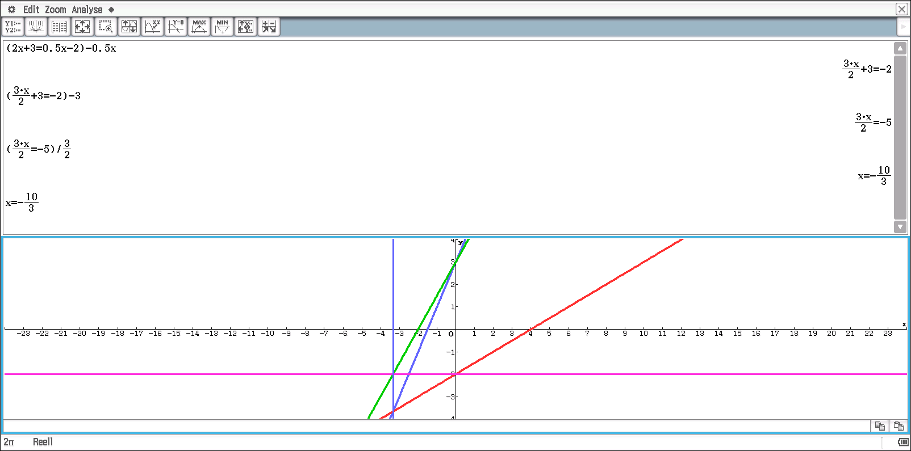
Fig. 1 Solving linear equations

We start with the equation 2x + 3 = 0,5x – 2 (see fig. 1). You put the equation in brackets and put the conversion behind. For students it is helpful to do this because they only have to think about the way of conversation and the calculator will do the calculation. Each part of the equation is the term of a linear function. Therefore you can easily show the corresponding graph. The solution of the equation is the x-value of the point of intersection. The y-value changes. So it is necessary to discuss the connections between changes in algebra and geometry.
The following mistake is quite popular:
3x + 4 = 7 l -3
x + 4 = 4
The CAS will show the student that his idea will lead to: 3x + 1 = 4. So the CAS will help to prevent those kinds of mistakes.
The next example will show the connection between a constructed curve and the square function.

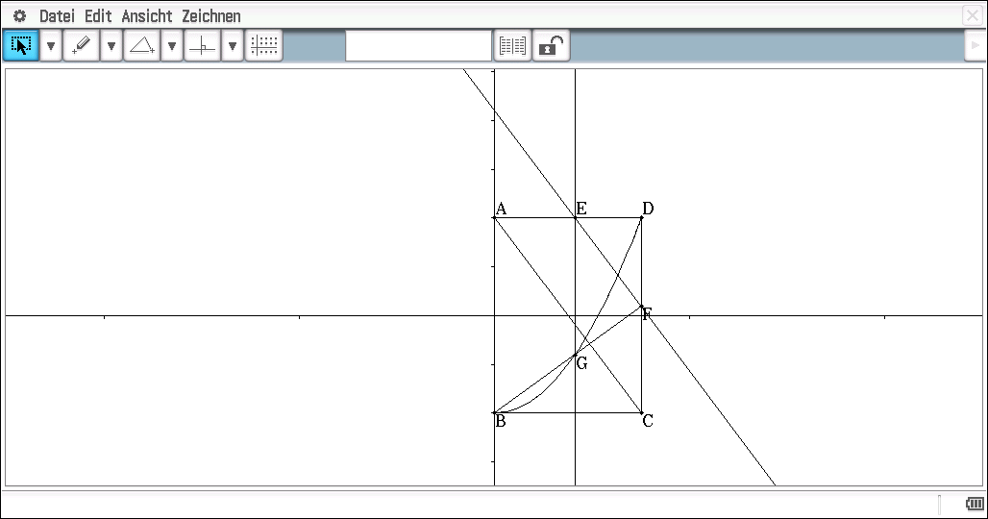
Fig. 2 Constructing a parabolic curve

The rectangle ABCD is constructed (see fig. 2). The point E is put on the line AD and a parallel to the diagonal AC is drawn. F is the point of intersection and is connected with the point B of the rectangle. The point G is the point of intersection between the line BF and the parallel to the line DC through E. You will get the parabolic curve by animation of the point E. The question is whether it is true that you have got really a parabolic curve. The different coordinates of the point G are saved by the ClassPad. Therefore it is possible to work with them in the spreadsheet (see fig. 3).

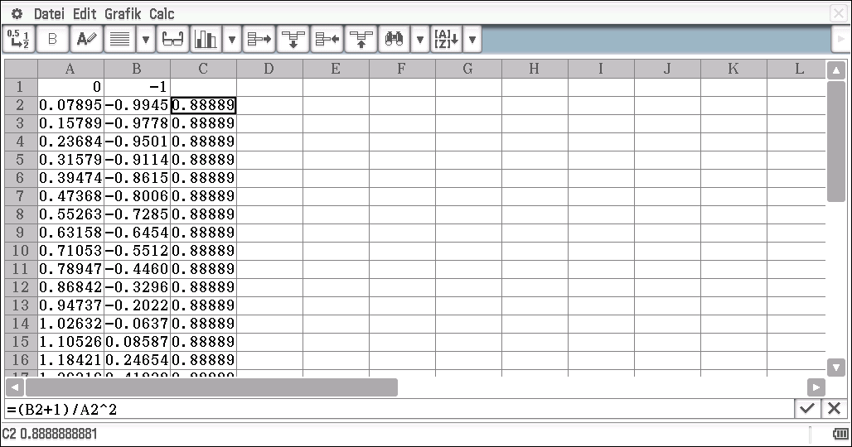
Fig. 3 Analysing the data

This is not a proof of course, but it gives the students an idea of working with data. The proof has to be done afterwards in the classroom. And the question whether a proof is necessary or not must be put up for discussion.

The last example will deal with a problem for older students. We want to get a formula for the curvature of a graph of a function. Therefore you can start with a special function and a special point.

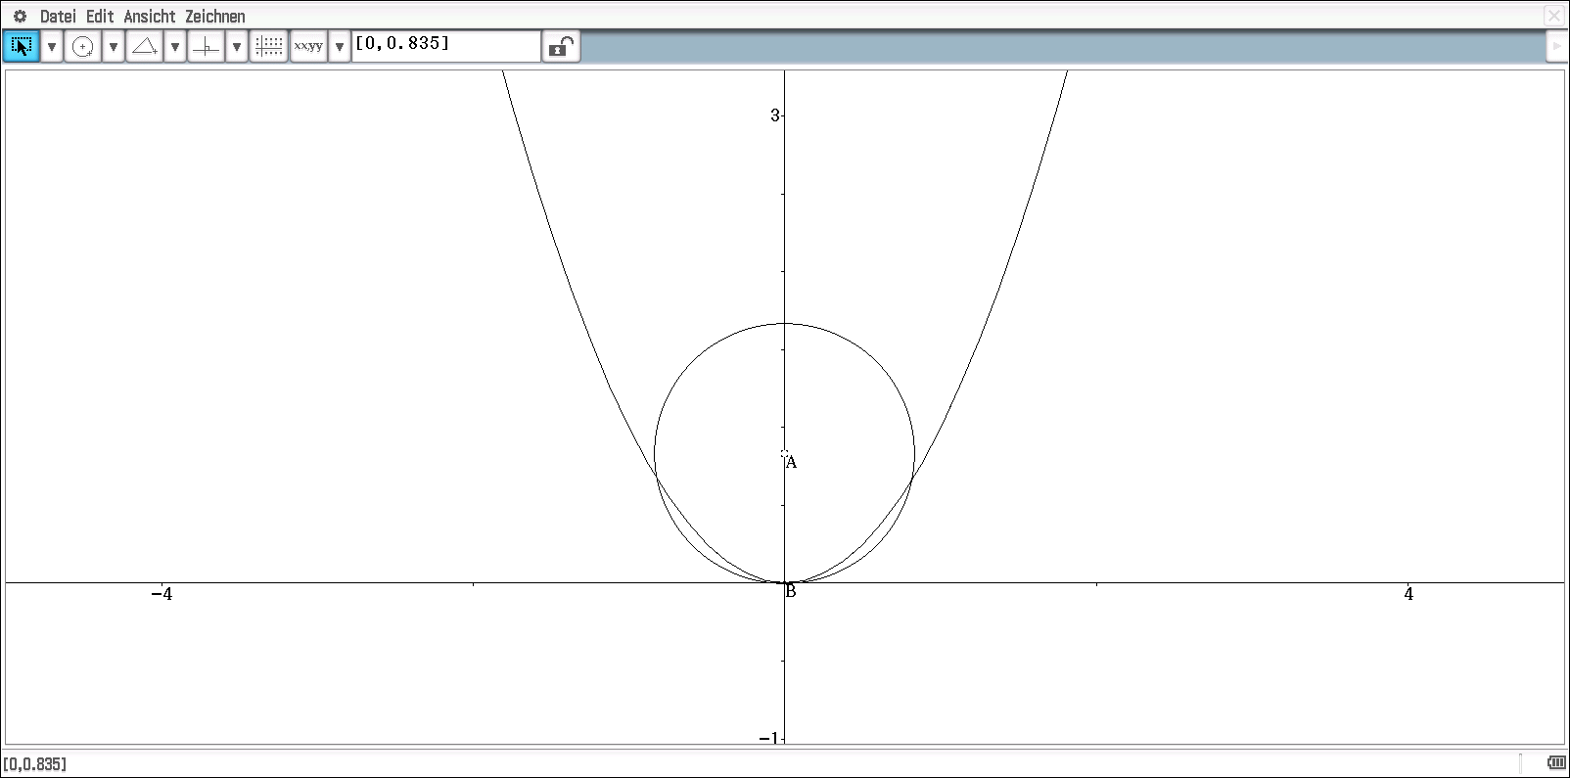
Fig. 4 Parabolic curve and responding circle

We discuss the graph of the function f(x) = x² and the point (0/0). A circle is constructed with centre A, which is variable on the y-axis, and the point B(0/0). The students can find out that the circle and the parabolic curve have one or three common points. The crossing-point is of special interest. This leads to the definition of what is meant by the curvature of a graph.
In the situation of the crossing-point the following equations must be true:
Square function: f(x) = x² Part of the circle: $c\left(x\right)= r- \sqrt{r^{2}- x^{2}}$
The three equations:
f(0) = c(0) f´(0) = c´(0) f´´(0) = c´´(0)
You can generalize those three equations to any function and any point and a CAS like the ClassPad will be able to create the formula.

